**Sitecore Hackathon 2020**

**Module purpose:** This is module/code is for the ‘Sitecore Hakathon Website’. Once we install the code into Sitecore, the website will get created. Here we are using Sitecore helix architecture with the help of Sitecore Habitat. This module will give user good user experience.

**Module Sitecore Hackathon Category:** Sitecore Hackathon Website

**How does the end user use the module?**

Following are the steps for the installation of the website.

* Install Sitecore 9.3 on local.
* Take the branch from
* Do the prerequisites for Helix based solution (Npm Install, and others if need).
* Rebuild the solution.
* Run the default gulp task from Task runner.
* Run Unicorn manually if it doesn’t work.

Once task is completed run the site and will get a completely new experience of Sitecore Hackathon website.

Following is the site with few screenshots:

Header: As every website will have logo, Main Navigation and search bar.

**Home page**: Carousel: which contains detail about current and previous years Hakathon.



The page followed with few Tiles related to Hakathon for previous years.

In ‘Hackthons’ will have all the list of previous year.

**Hakathon 2019:** will have the details about the Hackathon specific to that year. This will contain details related What topic, Submission Requirements, prizes, details of Judges details are accordions we need click on it, it will expand the content and about all participants list follows.



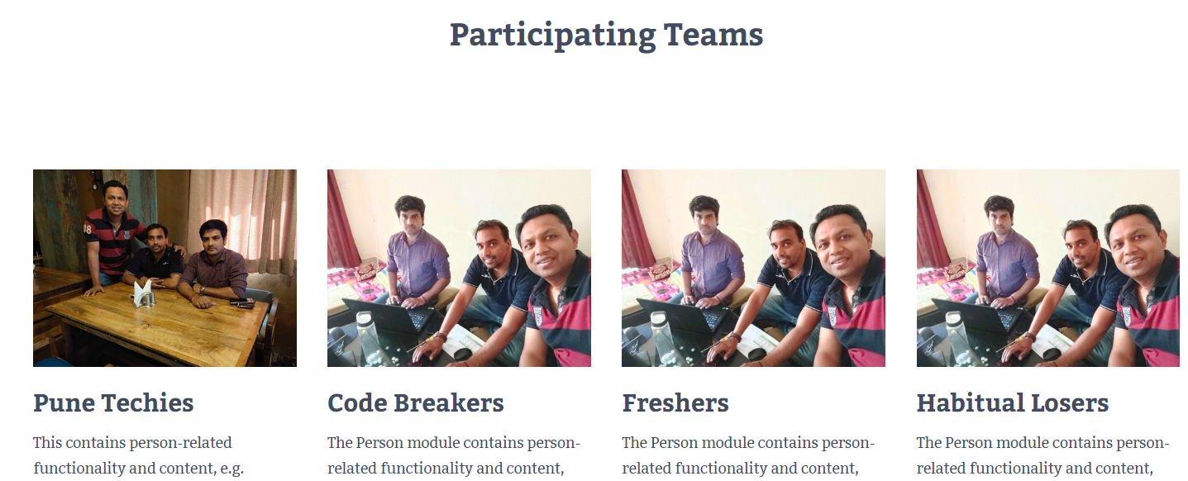

If we click on any of the participating team, Detail page will get displayed here